

# What is QuanClick

QuanClick is a user configurable mouse and keyboard code generator.

It reacts to presses from a 6 button keypad and sends sequences of mouse or keyboard control codes over USB just like a real mouse or keyboard would do as you move or press them.

Because you can send sequences of codes (or macros) you can replace many mouse or keyboard actions with just one button press.

For example you can program one button to fill in your entire email address with just one click.

# Building the device

## Connect up the buttons

Attach the pins from one end of the multiway cable to the pin header on the keypad

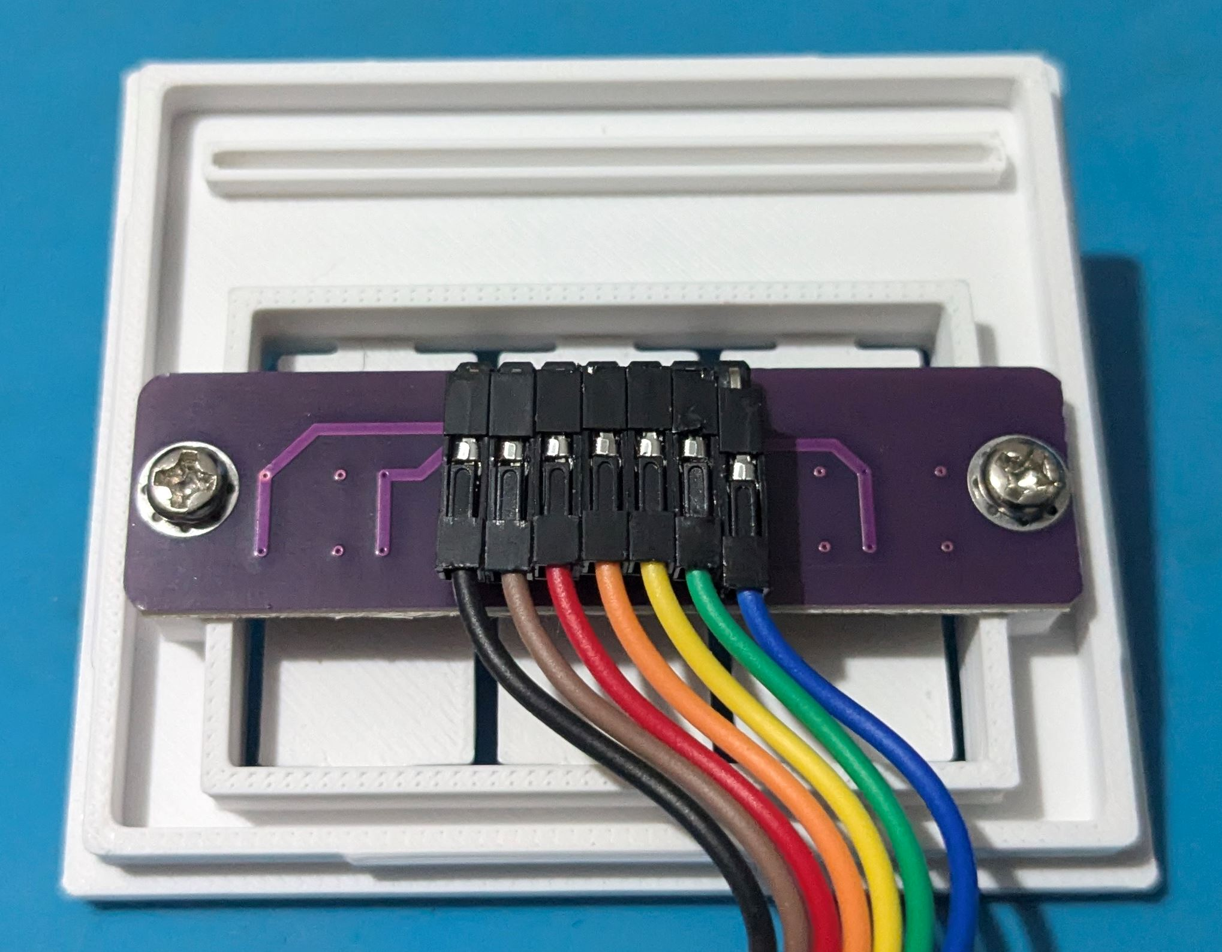

Your multiway cable may not have the same coloured wires as in this photo - that’s not important, just that they are all different colours so you can easily identify them either end.

Just make sure all the connectors are pushed in fully.

The connection to the left (in this picture the pin with the black wire) is the common connection, the other 6 are each of the buttons.

## Insert the Pico

Carefully insert the Pico into the printed slot as shown in the photo below. Insert one corner first then work the other corner in by pushing down on the edge of the board. It is a firm fit but be careful not to damage the board .

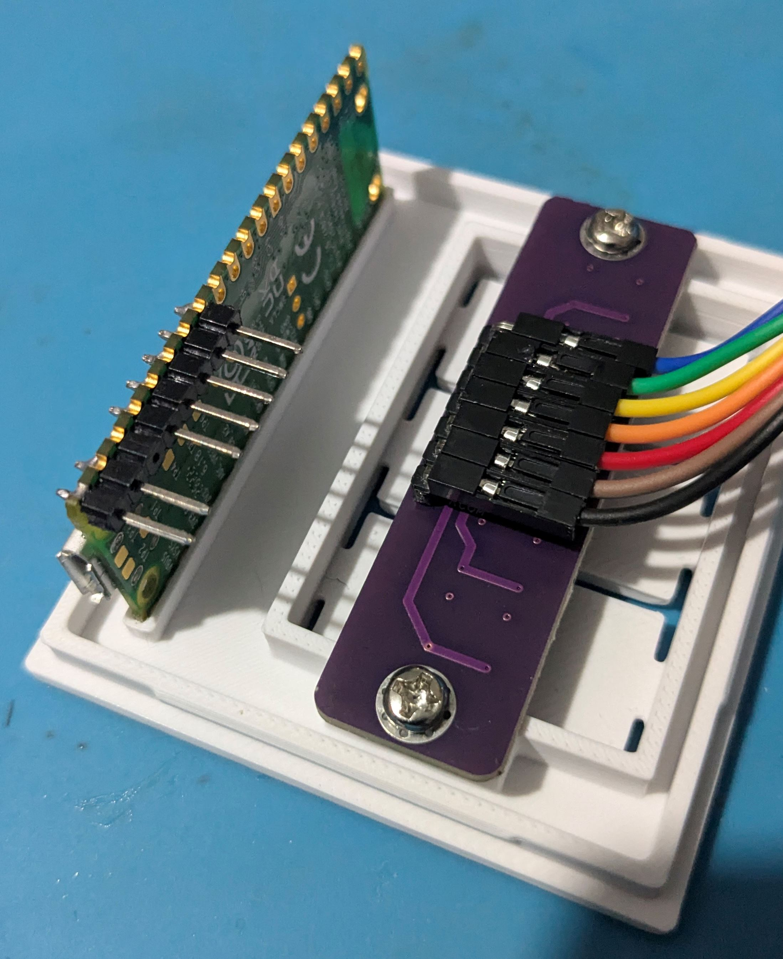

## Connect the Pico

Connect the wires to the Pico as shown in the photo matching your appropriate colours between button board and Pico.

Note the gap between connection 2 and 3.

Check that the common wire on the button board is connected to the 7th end connection pin on the Pico

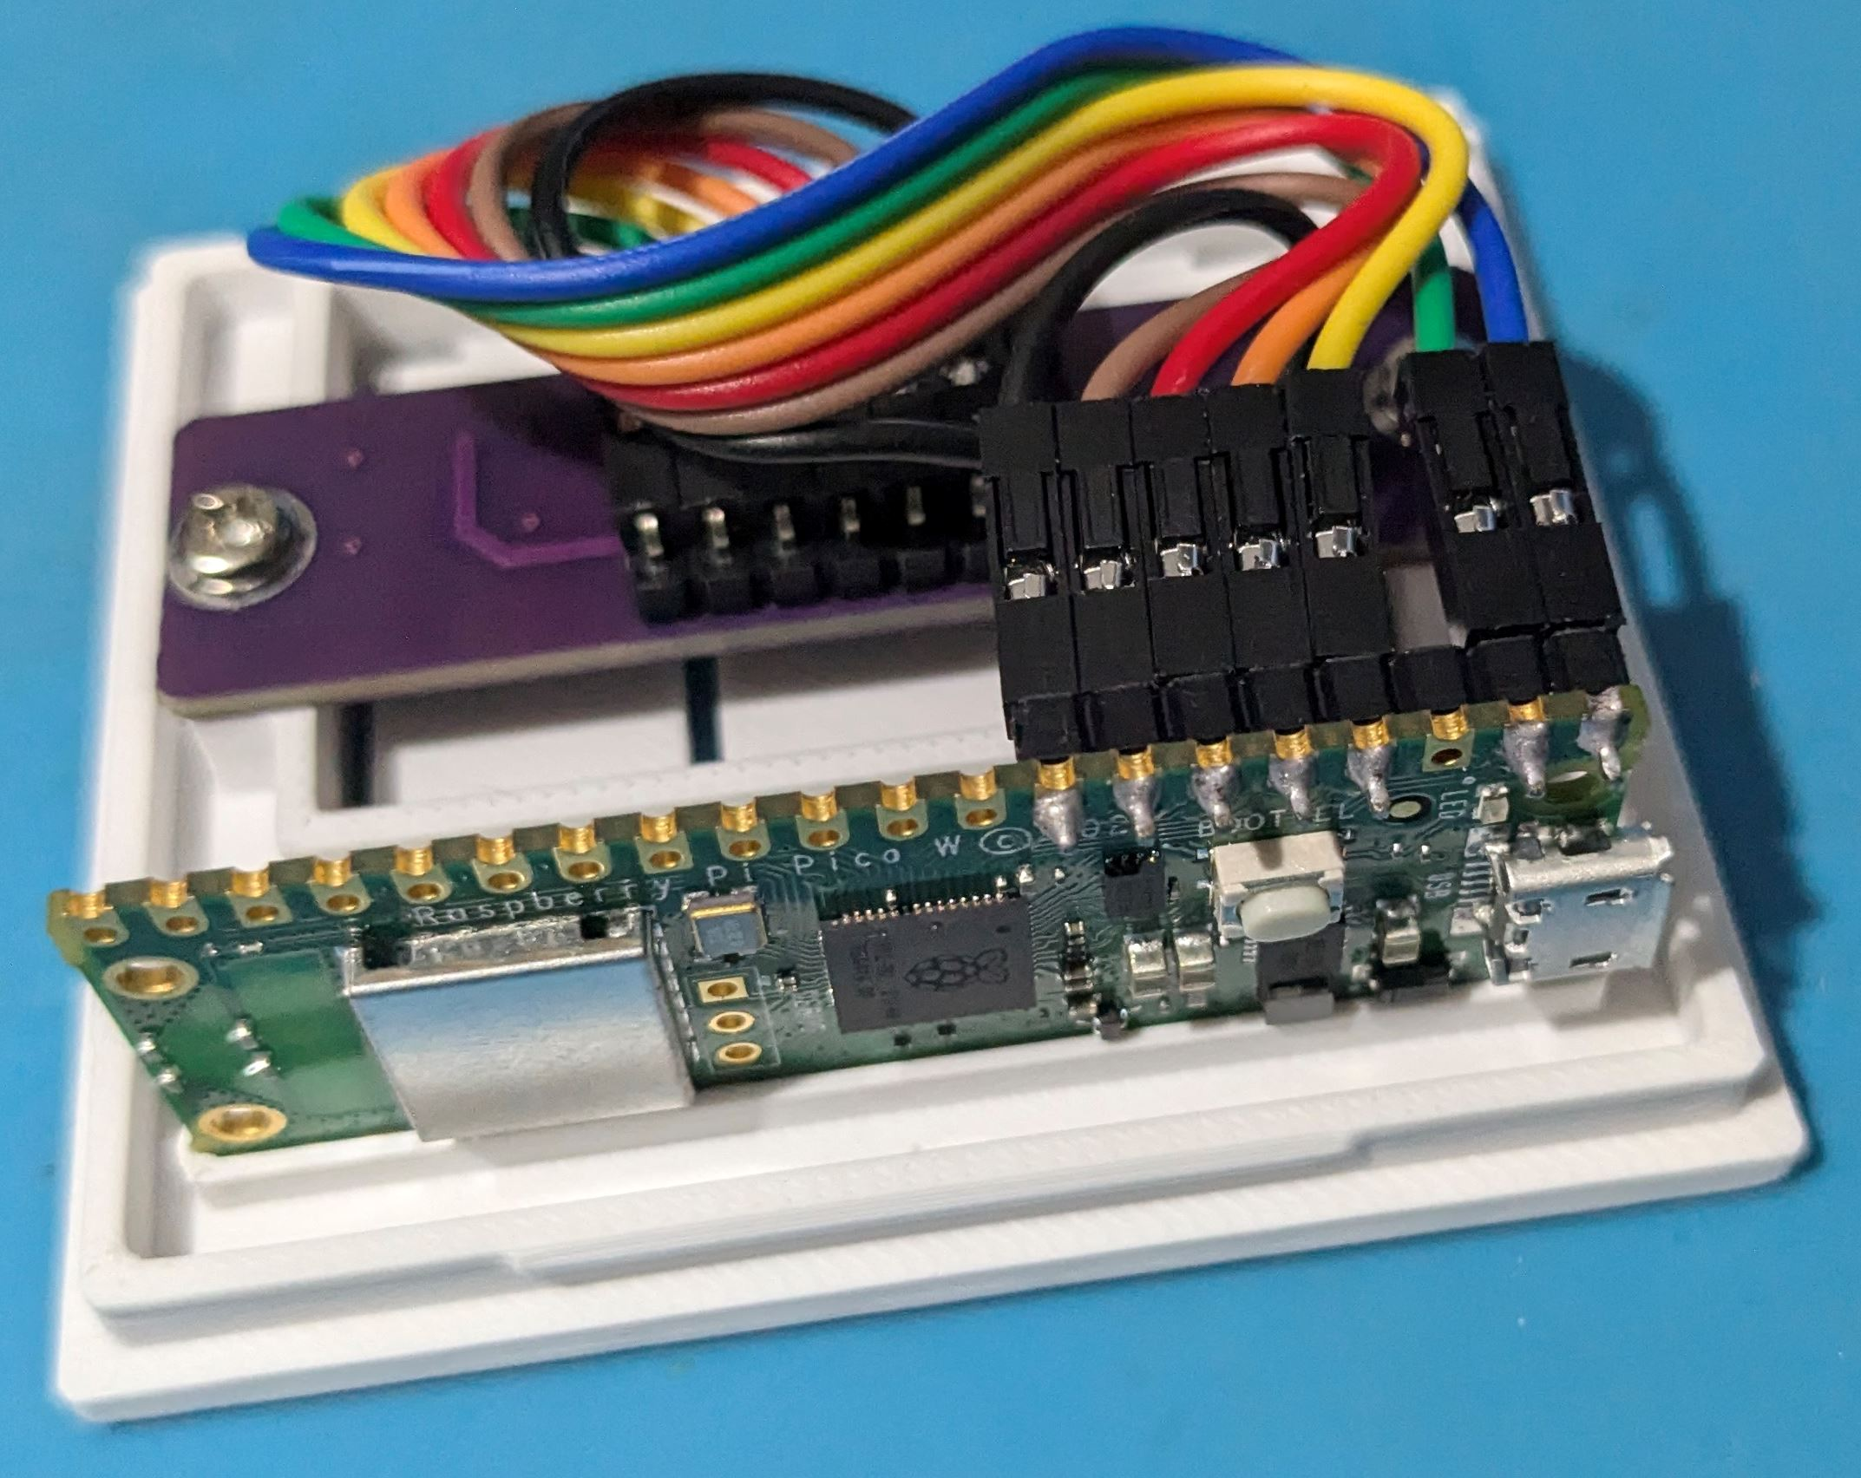

## Close the lid

Fit the lid onto the box by aligning the left (non-USB socket) side of the lid first

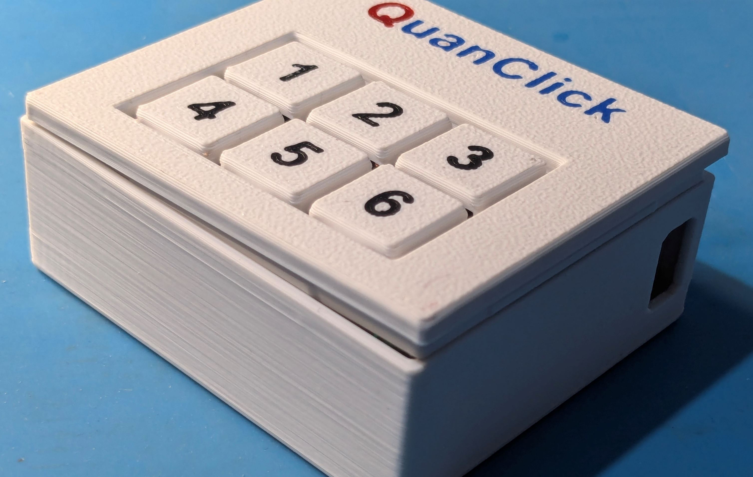

## Check board alignment

Look through the side USB window and check that the bottom of the Pico board is matched into the slot in the base of the case as shown in the photo below

If the board is not aligned then lift the lid and gently move the Pico in its lid slot and try again.

Once the board aligns well then click the lid down.

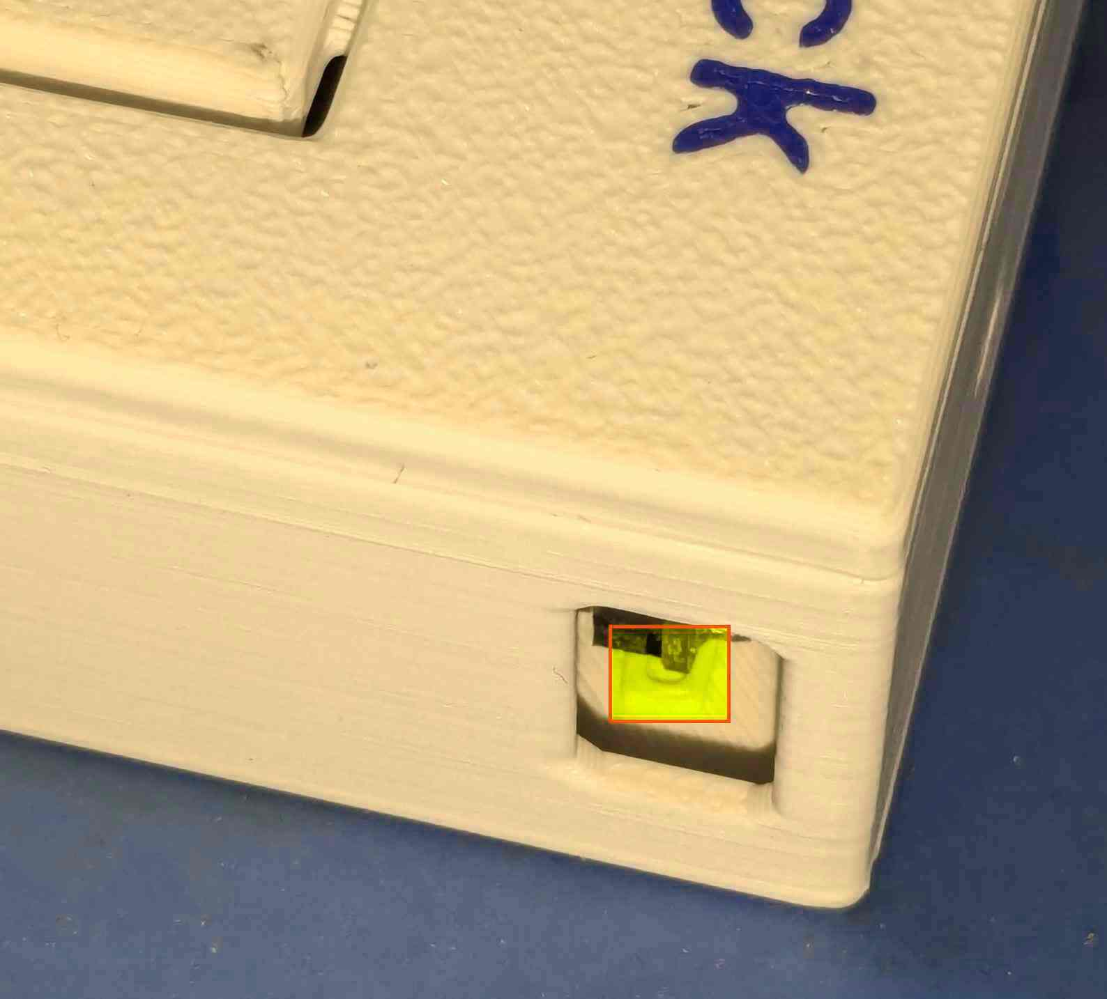

## Check MicroUSB alignment

Look in the side USB window and check the MicroUSB socket sits square in the hole.

Insert the MicroUSB cable into the Pico

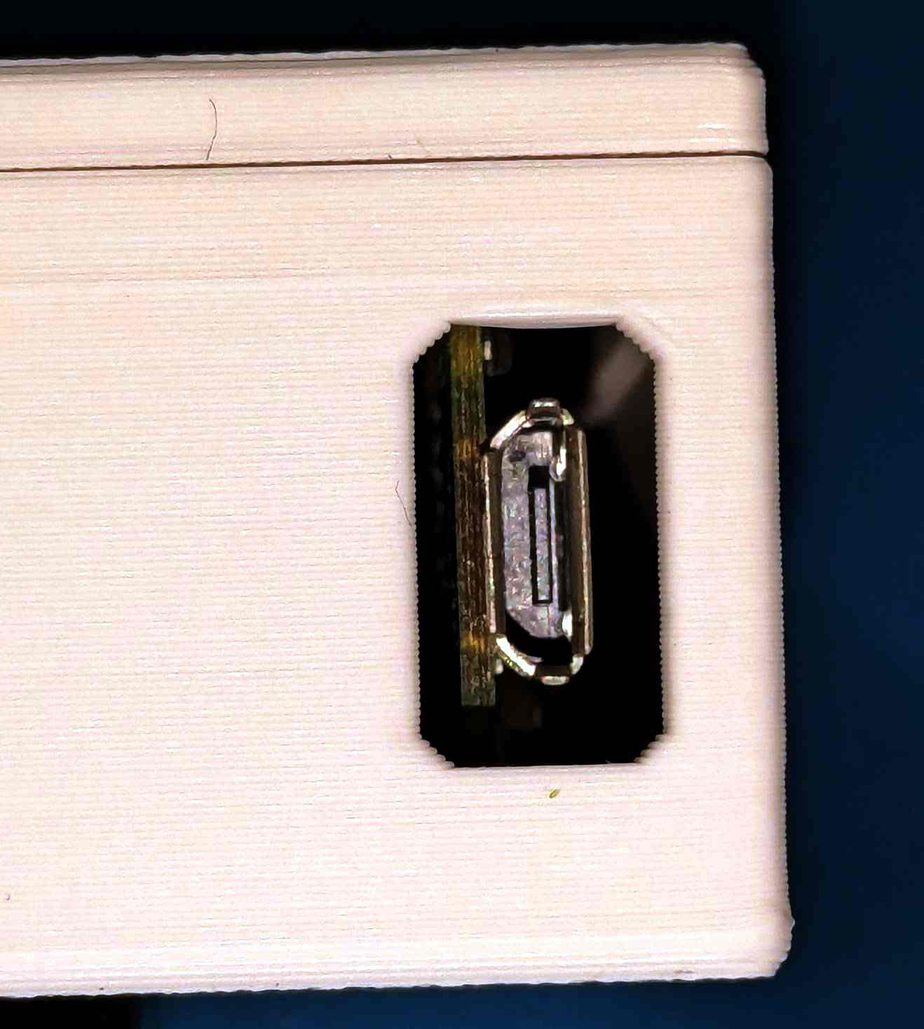

# Setup the Pico

## Plug in the Pico into your computer

* Wait whilst Windows install the com port
* Unplug the Pi Pico

## Put the Pico into UF2 download mode

* Hold down the BOOT/SEL button on the Pi Pico using a small screwdriver through the hole in the case
* Plug in Pi Pico
* Release the BOOT/SEL button
* Windows will open an explorer window

# Adding CircuitPython to the Pi Pico

## Download the CircuitPython 9.1.4 .UF2 file

* + https://circuitpython.org/board/raspberry_pi_pico/
  + drag and drop the download into the Pi Pico root folder

# Donload and install Thonny with Python

## Thonny website

* https://thonny.org/

## Github download for portable version

* https://github.com/thonny/thonny/releases/download/v4.1.6/thonny-py38-4.1.6-windows-portable.zip
* Extract all to C:\Users\{user_name}\Thonny
* Run Thonny.exe
  + Language: English (UK)
  + Initial Settings: Raspberry Pi (simple)

Click on the lower Thonny menu

* Configure interpreter...

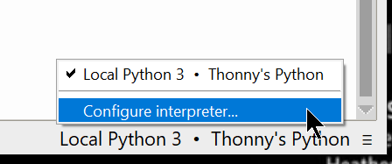

Select an interpreter

* CircuitPython (generic)
* Select OK

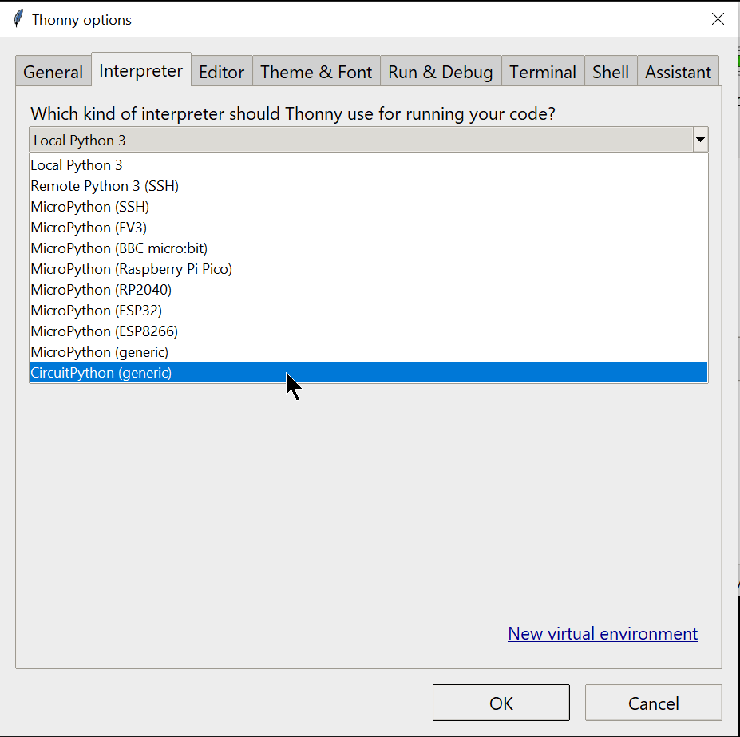

Thonny should detect the Pico com port and show in the lower menu

You are now setup to program your Pico

# Programming the Pico

## QuanClick source code

Obtain the source code from

* CHANGE_ME {insert web link here}

Open the QuanClick.py python file in Thonny

* File…
  + Open…
    - This Computer
    - Navigate to file and select Open

Run the script

* Run…
  + Run current script

## Changing the macros

The code can be modified to set personal actions for any key, some examples pre-exist in the source code

The definitions are listed in the “button_actions” array at line 27 of the code

There are 3 types of actions – keyboard, mouse_move and mouse_click

The keyboard actions contain Keycode types which are encoded codes for each key and special keys like SHIFT and WINDOWS.

The mouse_move actions contain an x,y co-ordinate move

The mouse_click actions contain Mouse types like LEFT_BUTTON